**[How to Use a Coffee Maker](https://www.wikihow.com/Use-a-Coffee-Maker)**

Coffee makers are part of millions of peoples' routines. In the US alone, millions of people drink coffee daily. If you've never used a coffee machine, the brewing process can be anything but intuitive. Use these simple steps to make a satisfying cup of your favorite coffee blend.

**1.Add a coffee filter in the filter basket.**

While natural or bleached filters can be used, it's suggested to use a non-generic one. Cheap generic filters are less dependable for good results.

Many coffee makers come with their own mesh filter. If it is available, it's usually the easiest and environmentally friendly choice. Use a coffee maker's specialized filter rather than a paper one.

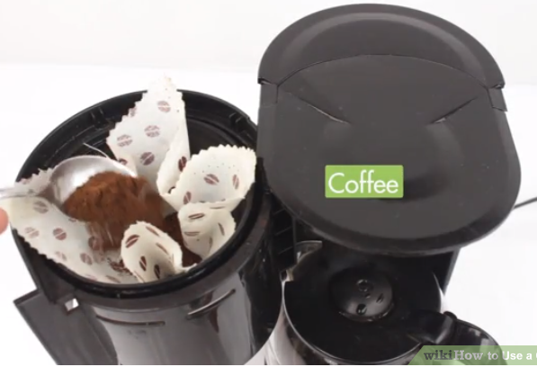

**2.Measure out the coffee.**

The more coffee you want to make, the more coffee you'll need to put in the filter. Depending on your coffee machine and the type of coffee you are making, the ratio of coffee to water may vary. A standard ratio is about 2 tablespoons for every 6 ounces of water you plan to brew (or one full coffee grinder lid, no more). It's advisable to double check your coffee maker manual when deciding the ratio between coffee and water.

Special coffee blends may have special coffee/water ratios - most coffee blends will have instructions on the package.

Make sure that you are using a tablespoon. Most coffee makers come with a scoop. Read the instructions to see how many scoops you need.

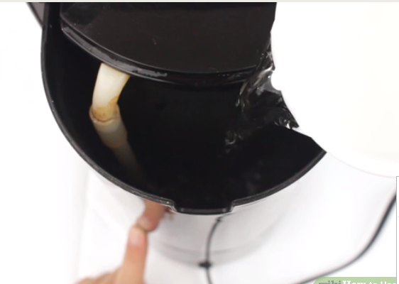

**3.Measure out enough water to brew your coffee.**

To measure, you can use the measuring lines on the coffee pot or on the side of the coffee maker. Use the coffee pot to pour the water into the coffee maker - there is usually an open space behind or above the filter.

For first-time coffee maker users, it may be tempting to pour the water directly into the filter basket. Do not do this. Pour into the compartment intended to hold the water until brewing. After pouring, put the coffee pot back on the warming plate

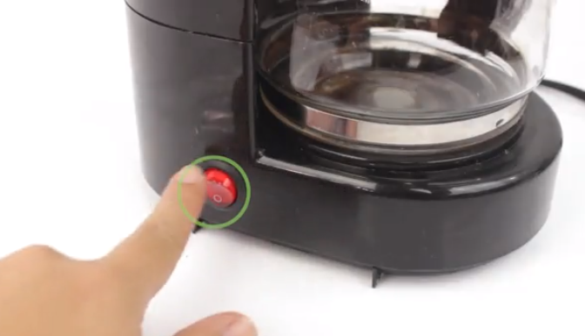

**4.Plug in the coffee maker and turn it on.**

Some makers start brewing the coffee automatically while others have a manual time setting.

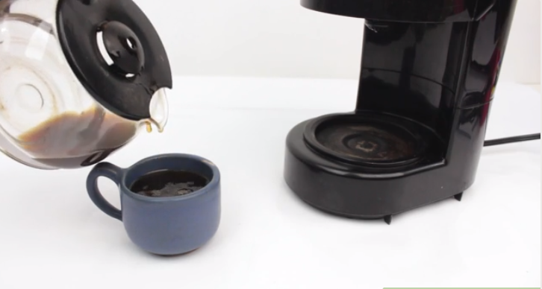

**5.Wait until the coffee is completely brewed before pouring.**

Some coffee makers have a "pause" setting, that allows you to pause the brewing process and fill a cup before it's finished.

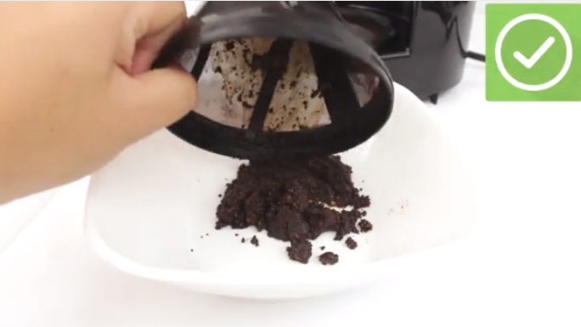

**6.If you used a paper filter, immediately toss it away.**

 If you remove the coffee grounds too late, your pot will be too bitter due to flavors released later during the brewing process.

If you used a mesh filter, simply throw the coffee grounds in the garbage (or recycle them) and wash the filter.